2. Timeline Chart
Weather Forecasting Management System
Project Plan – Gantt Chart (13 Weeks)
Task : Person | 1 | 2 | 3 | 4 | 5 | 6 | 7 | 8 | 9 | 10 | 11 | 12 | 13
A : Utsa
B : Shohanur
C : Amartay
D : Aminul
E : Utsa
F : Shohanur
G : Amartay
H : Aminul
I : Arman
J : Arman
K : Utsa & Amartay
L : All
Activity Key:
A : Requirement Analysis | G : Alert System Module
B : System Architecture | H : Route Optimization Module
C : UI/UX Design | I : Historical Data Module
D : Database Design | J : Integration Testing
E : Auth Module (Login/Reg) | K : System Testing
F : Weather Update Module | L : Final Review & Deployment
Person Assignments: Utsa Mazumdar (A,E) | Shohanur Rahman (B,F) | Amartay Das (C,G) | Aminul Islam Shanto (D,H) | Arman Rahman (I,K,L)

3. SOFTWARE REQUIREMENTS SPECIFICATIONS (SRS)
3.1 Scopes and Features
3.1.1 Profile Management
Features:
- Users can create new accounts and securely login using valid credentials.
- Users can update or modify their personal details and preferences.
- The system ensures role-based access (e.g., general users, authorities, media).
- System Administrator manages user accounts and roles

3.1.2 Weather Updates and Alerts
Features:
- System Administrator updates weather data.
- Users can view real-time weather updates and forecasts for specific locations.
- Users receive automatic weather alerts, official warnings, and safety
- instructions during severe or extreme weather conditions.

3.1.3 Warning and Emergency Response Coordination
Features:
- Disaster management authorities can issue early public warnings through the alert network.
- The system enables disaster management authorities to coordinate and monitor emergency response operations.
- System Administrator monitors the alert system for errors or delivery failures.

2.1.4 Route Optimization
Features:
- Transportation services can plan alternative and safer routes based on forecasted weather conditions.
- The system provides data on visibility, wind speed, and storm activity to minimize travel risks.
2.1.5 Broadcast Forecasts and Alerts
Features:
- Media and news agencies can integrate live weather data into news updates and digital platforms.
- The system provides press-ready summaries, charts, and visualizations for quick dissemination.
2.1.6 Historical Forecast Data
Features:
- System Administrator maintains database integrity and backups.
- Disaster management authorities can access and analyze historical weather data for comparison and trend observation.

Use Case Diagram:
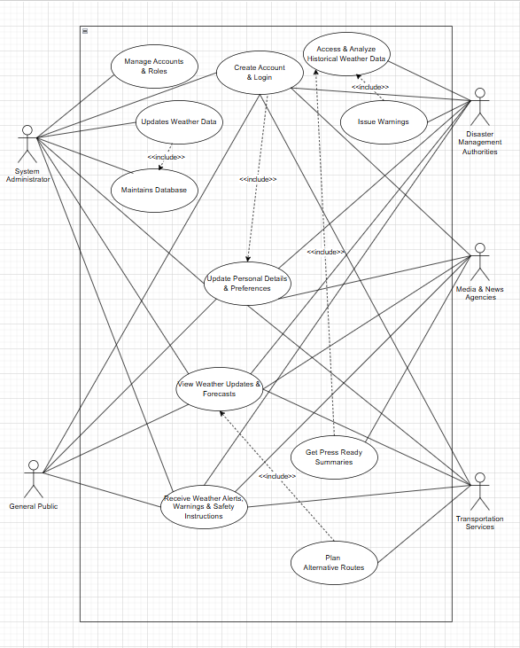

Description:
The use case diagram represents the functional overview of the Weather Forecasting Management System and illustrates the interactions between the system and its key stakeholders. The System Administrator manages user accounts, updates weather data, and maintains the system database to ensure reliable operation. The General Public can view weather updates, forecasts, and receive alerts, warnings, and safety instructions for daily planning. Disaster Management Authorities access and analyze historical weather data and issue warnings during critical situations. Media and News Agencies obtain press-ready summaries to disseminate accurate weather information to the public. Transportation Services use weather forecasts to plan alternative and safer routes.
Overall, the diagram shows how authenticated users interact with the system to access weather information, manage emergencies, and support informed decision-making.

3.2 User Story Table
Table-1
As A/An | I want to | So that | Acceptance Criteria
System Administrator | Create an account | I can access personalized features | Registration form available; fields validated; account created successfully.
 | Login / logout | I can securely access the system | Valid credentials allow login; invalid ones show error; session ends on logout.
 | Reset my password | I can regain access if I forget it. | “Forgot Password” option works; reset link or OTP sent; password updated.
 | Edit my profile | My information stays updated. | Admin can modify name, email, preferences; changes saved.
 | Search for a location | I can view weather data for that place. | Search bar works; location suggestions shown; forecast loads accurately.
 | Manage user accounts | Forecasts remain accurate. | Weather data update panel works; system refreshes data globally.
 | Monitor alert delivery | System errors can be identified. | Alert logs visible; system highlights failed alerts.
 | Backup and restore features | Data safety is ensured. | Automatic/manual backup options; restore functionality operational.
General Public | Create an account | I can access personalized features | Registration form available; fields validated; account created successfully.
 | Login / logout | I can securely access the system | Valid credentials allow login; invalid ones show error; session ends on logout.
 | Reset my password | I can regain access if I forget it. | “Forgot Password” option works; reset link or OTP sent; password updated.
 | Edit my profile | My information stays updated. | General public can modify name, email, preferences; changes saved.
 | Search for a location | I can view weather data for that place. | Search bar works; location suggestions shown; forecast loads accurately.
 | View real-time weather updates | I can plan my day. | Dashboard shows temperature, humidity, wind, precipitation, etc.
 | Check hourly and daily forecasts | I can plan ahead. | Hourly and multi-day forecasts visible; charts/tables displayed properly.
 | Receive severe weather alerts | I stay safe. | Alerts automatically delivered through user’s chosen notification method.
Disaster Management Authority | Create an account | I can access personalized features | Registration form available; fields validated; account created successfully.
 | Login / logout | I can securely access the system | Valid credentials allow login; invalid ones show error; session ends on logout.
 | Reset my password | I can regain access if I forget it. | “Forgot Password” option works; reset link or OTP sent; password updated.
 | Edit my profile | My information stays updated. | Disaster Management Authority can modify name, email, preferences; changes saved.
 | Search for a location | I can view weather data for that place. | Search bar works; location suggestions shown; forecast loads accurately.
 | Issue emergency warnings | The public is informed quickly. | Alert creation panel available; alerts broadcast instantly.
 | Monitor emergency response operations | I can coordinate properly. | Weather severity dashboards and alert logs available.
Media & News Agencies | Create an account | I can access personalized features | Registration form available; fields validated; account created successfully.
 | Login / logout | I can securely access the system | Valid credentials allow login; invalid ones show error; session ends on logout.
 | Reset my password | I can regain access if I forget it. | “Forgot Password” option works; reset link or OTP sent; password updated.
 | Edit my profile | My information stays updated. | Media & News Agencies can modify name, email, preferences; changes saved.
 | Search for a location | I can view weather data for that place. | Search bar works; location suggestions shown; forecast loads accurately.
 | Access to verified forecasts | I can broadcast accurate updates. | Media portal shows real-time verified data.
 | Download reports | I can use them in news broadcasts. | System generates PDF/summary; charts export correctly.
Transportation Services | Create an account | I can access personalized features | Registration form available; fields validated; account created successfully.
 | Login / logout | I can securely access the system | Valid credentials allow login; invalid ones show error; session ends on logout.
 | Reset my password | I can regain access if I forget it. | “Forgot Password” option works; reset link or OTP sent; password updated.
 | Edit my profile | My information stays updated. | Transportation Services can modify name, email, preferences; changes saved.
 | Search for a location | I can view weather data for that place. | Search bar works; location suggestions shown; forecast loads accurately.
 | Access route-based weather insights | I can choose safer routes. | System shows weather hazards along route; suggests alternatives.
 | Access optimized routes | Travel risks are minimized. | System generates alternate routes considering weather hazards.

3.3 Requirements Traceability Matrix
This section presents the requirements of the Weather Forecasting Management System (WFMS) in a structured manner. The requirements are categorized according to different user roles to clearly define system responsibilities and access levels. Each requirement specifies the functional capabilities that the system must provide to meet user needs. The requirements are numbered using a standard hierarchical format, consistent with the project documentation guidelines.
3.3.1 Functional Requirements
System Administrator’s Requirements
Table-2
1.0 | User home page-All features availability
1.1 | Registration
1.1.1 | Taking name
1.1.2 | Taking email address
1.1.3 | Taking user name
1.1.4 | Taking password
1.1.5 | Taking confirm password
1.1.6
1.1.7
1.1.8
1.1.9
1.1.10 | Resetting the form
1.2 | Login
1.2.1 | Taking user name
1.2.2 | Taking password
1.2.3
1.2.3.1 | Submitting e-mail address and getting user info through our e-mail id
1.2.4 | Submission of the login
1.3 | Dashboard
1.3.1 | Profile Button
1.3.1.1 | Show name
1.3.1.2 | Show email address
1.3.1.3 | Show phone number
1.3.1.4 | Show date of birth
1.3.2 | Profile edit button
1.3.2.1 | Show existing name and take name
1.3.2.2 | Show existing email address and take email address
1.3.2.3 | Show existing phone number and take phone number
1.3.2.4 | Show existing date of birth and take date of birth
1.3.2.5 | Submitting the form
1.3.3 | Password reset button
1.3.3.1 | Type previous password
1.3.3.2 | Type new password
1.3.3.3 | Retype new password
1.3.4 | Search location button
1.3.4.1 | Show search bar
1.3.4.2 | Show location suggestions
1.3.4.3 | Load forecast accurately
1.3.5 | Manage user accounts button
1.3.5.1 | Update weather data panel
1.3.5.2 | Refresh data globally
1.3.6 | Weather alert button
1.3.6.1 | Show alert logs
1.3.6.2 | Highlight failed alerts
1.3.7 | Logout button
1.3.7.1 | Show login page

General Public Requirements
Table-3
1.0 | User home page-All features availability
1.1 | Registration [ref System Administrator 1.1]
1.2 | Login [ref System Administrator 1.2]
1.3 | Dashboard
1.3.1 | Profile button [ref System Administrator 1.3.1]
1.3.2 | Profile edit button [ref System Administrator 1.3.2]
1.3.3 | Password reset button [ref System Administrator 1.3.3]
1.3.4 | Search location button [ref System Administrator 1.3.4]
1.3.5 | Real-time weather button( Route Finding)
1.3.5.1 | Shows temperature, humidity, wind, precipitation
1.3.5.2 | Show hourly and multi-day forecasts
1.3.5.3 | Display charts/tables
1.3.6 | Weather alert button(Red Zone, Green Zone)
1.3.6.1 | Take notification method
1.3.6.2 | Deliver automatic alert via notification

Disaster Management Authority Requirements
Table-4
1.0 | User home page-All features availability
1.1 | Registration [ref System Administrator 1.1]
1.2 | Login [ref System Administrator 1.2]
1.3 | Dashboard
1.3.1 | Profile button [ref System Administrator 1.3.1]
1.3.2 | Profile edit button [ref System Administrator 1.3.2]
1.3.3 | Password reset button [ref System Administrator 1.3.3]
1.3.4 | Search location button [ref System Administrator 1.3.4]
1.3.5 | Warning button
1.3.5.1 | Show alert creation panel
1.3.5.2 | Broadcast alert
1.3.6 | Emergency response button
1.3.6.1 | Show weather severity dashboard
1.3.6.2 | Show alert logs
1.3.7 | Logout button [ref System Administrator 1.3.7]

Media & News Agencies Requirements
Table-5
1.0 | User home page-All features availability
1.1 | Registration [ref System Administrator 1.1]
1.2 | Login [ref System Administrator 1.2]
1.3 | Dashboard
1.3.1 | Profile button [ref System Administrator 1.3.1]
1.3.2 | Profile edit button [ref System Administrator 1.3.2]
1.3.3 | Password reset button [ref System Administrator 1.3.3]
1.3.4 | Search location button [ref System Administrator 1.3.4]
1.3.5 | Forecast button
1.3.5.1 | Show verified real-time data on media portal
1.3.6
1.3.6.1 | Generate PDF/summary
1.3.6.2
1.3.7 | Logout button

Transportation Services Requirements
Table-6
1.0 | User home page-All features availability
1.1 | Registration [ref System Administrator 1.1]
1.2 | Login [ref System Administrator 1.2]
1.3 | Dashboard
1.3.1 | Profile button [ref System Administrator 1.3.1]
1.3.2 | Profile edit button [ref System Administrator 1.3.2]
1.3.3 | Password reset button [ref System Administrator 1.3.3]
1.3.4 | Search location button [ref System Administrator 1.3.4]
1.3.5 | Alternative route button
1.3.5.1 | Show weather hazards along route
1.3.5.2 | Generate alternate routes considering weather hazards
1.3.6 | Logout button [ref System Administrator 1.3.7]

